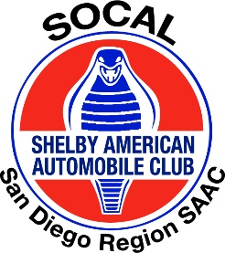

All Things Carroll Shelby Car Show

Nane” __________________________________ Telephone: ______________________
Email Address: ___________________________________ Your Registration confirmation will be emailed
Each Registered car gets a Dash Plaque and a T-shirt, please choose your size:
Adult S, M, L, XL, XXL, 3XL, 4XL Circle one.
Additional shirts can be ordered prior to the show:
$15.00 for SM, M, L, & XL, $18.00 for 2XL, 3XL, & 4 XL.
Car Year: ______ Car Make: ______________: Car Model _________________________
Car Class (Click Here Classification) ___________, Car Club ________________________
Please mail on or before July 30 2023 5:00pm
Questions: (858) 229-0161, SoCalSAAC@gmail.com or Koncept@san.rr.com
To Register by Mail; Make $40 check payable to: SoCal SAAC, fill out this form and send to “SoCal SAAC Car Show 1991 Trousdale Place., Escondido, CA 92029

Liability Release: All entrants and participants hereby release and discharge The SOCAL Shelby American Automobile Club and all sponsors from any known or unknown damages, injuries or claims that may occur on the way to, during the event, or after the event.

